SOFTWARE PERSONNEL MANAGEMENT SYSTEM

A PROJECT REPORT
Submitted by
Team Members name Register No
1. Harris J 910022104701
2. Prasanna R 910022104303
3. Suguna S 910022104031
4.Vidya S 910022104032

in partial fulfilment for the award of the degree
of
BACHELOR OF ENGINEERING
IN
COMPUTER SCIENCE AND ENGINEERING

ANNA UNIVERSITY REGIONAL CAMPUS MADURAI


NOVEMBER 2024

ANNA UNIVERSITY: CHENNAI 600 024

BONAFIDE CERTIFICATE

Certified that this project “SOFTWARE PERSONNEL MANAGEMENT SYSTEM” is the bonafide work of Harris J (910022104701), Prasanna R (910022104303), Suguna S (910022104031) and Vidya S (910022104032) who carried out the project under my supervision.

Team Members name Register No
1. Harris J 910022104701
2. Prasanna R 910022104303
3. Suguna S 910022104031
4.Vidya S 910022104032

CHAPTER  NO: | TITLE PAGE  NO.
TABLE OF CONTENTS

ABSTRACT
LIST OF FIGURES
LIST OF ABBREVIATIONS

1. INTRODUCTION
  - Domain Introduction
  - Project Introduction
- SCOPE
  - Application Area Identification
  - Stakeholder Identification
3. REQUIREMENT GATHERING COLLECTION
4. SYSTEM ANALYSIS
4.1 Existing System
4.2 Disadvantages / Drawback / Limitation
3.3 Proposed System / New Features Employees
5. FEASIBILITY STUDY
5.1 Technical Feasibility
5.2 Operational Feasibility
5.3 Financial Feasibility
6. SYSTEM REQUIREMENTS
6.1 Hardware Requirements
6.2 Software Requirements
6.3 Software Description
7. SYSTEM DESIGN
7.1 Usecase Diagram
7.2 Activity Diagram
7.3 Sequence Diagram
7.4 Class Diagram
7.5 Collaboration Diagram

8. SYSTEM IMPLEMENTATION
8.1 Modules of the project
8.2 Module Description
9. EXPERIMENTAL RESULTS
9.1 Screenshots
10. RESULTS AND FINDINGS

  - Performance Evaluation
  - Inferences
11. CONCLUSION AND FUTURE
ENHANCEMENT
11.1 Conclusion
11.2 Future Enhancement
12. REFERENCES

ABSTRACT
The Software Personnel Management System (SPMS) is a comprehensive web-based application designed to optimize personnel management processes in an organization. It aims to streamline operations such as employee information management, attendance tracking, payroll processing, leave management, and performance evaluation. Traditional personnel management methods rely on manual record-keeping, which is time-consuming, error-prone, and inefficient. This system eliminates manual processes by integrating automation and database-driven solutions, ensuring accuracy, security, and efficiency. The SPMS provides role-based access control, allowing administrators, HR personnel, and employees to interact with the system based on their authorization levels. Employees can update their personal information, request leaves, and view their attendance records, while HR managers can track employee performance, process payroll, and allocate projects. The system also includes automated alerts for low attendance and pending approvals, ensuring timely updates and communication. The proposed system leverages a robust database to store employee records securely. The use of a responsive web interface ensures accessibility across multiple devices. The system is developed using a user-friendly and scalable technology stack, including Python (Flask), MySQL/SQLite for data management, and HTML, CSS, and JavaScript for the frontend design. Security measures such as encryption and authentication are implemented to safeguard sensitive employee information. By implementing SPMS, organizations can significantly improve workforce productivity, enhance operational transparency, and minimize administrative workload. The system's efficiency is further enhanced by incorporating data-driven analytics, which helps HR personnel in decision-making. Future enhancements may include AI-powered performance evaluation, biometric-based attendance tracking, and cloud deployment for improved accessibility. Overall, this project provides a unique and modernized approach to personnel management, addressing key organizational challenges and ensuring seamless workflow automation.

LIST OF FIGURES

- Figure 1: Use Case Diagram – Describes the interactions between users and the system functionalities.
- Figure 2: Class Diagram – Illustrates the structure of the system, showing classes, attributes, and relationships.
- Figure 3: Activity Diagram – Depicts the flow of control or activities in various modules.
- Figure 4: Sequence Diagram – Represents the sequence of messages exchanged between objects in a particular scenario.
- Figure 5: Collaboration Diagram – Shows how objects interact based on their relationships in a collaborative structure.

LIST OF ABBREVIATIONS

- HR – Human Resources
- SPMS – Software Personnel Management System
- UI – User Interface
- DBMS – Database Management System
- SQL – Structured Query Language
- HTML – HyperText Markup Language
- CSS – Cascading Style Sheets
- JS – JavaScript
- CRUD – Create, Read, Update, Delete
- OTP – One Time Password
- ID – Identification

1.INTRODUCTION

  - Domain Introduction:

The Software Personnel Management System falls under the domain of Human Resource Management Systems (HRMS), a subset of enterprise resource planning. HRMS software is designed to streamline human resource operations like employee management, payroll, recruitment, leave handling, performance appraisal, and compliance tracking. This system aims to minimize manual work and improve productivity by automating and integrating these core HR functions in a centralized, digital environment.

1.2. Project Introduction:

This project aims to design and implement a user-friendly, secure, and efficient web-based Software Personnel Management System (SPMS) tailored for small to medium enterprises. The system simplifies HR-related operations by digitizing employee records, automating payroll processing, streamlining leave requests, and enabling performance tracking. With role-based access control for HR managers and employees, SPMS ensures data integrity, accessibility, and administrative transparency. Technologies like Flask (Python), MySQL, HTML, CSS, and Bootstrap are used to deliver a responsive and dynamic interface.

2.SCOPE

2.1. Application Area Identification

The SPMS can be deployed in:
- IT and software companies
- Educational institutions
- Hospitals and healthcare organizations
- Government departments
- Medium-scale manufacturing units
- Any organization with a need to manage HR operations digitally

  - Stakeholder Identification

The primary stakeholders of the system include:
- HR Administrators: Manage employee data, payroll, leave, and appraisals.
- Employees: View personal records, submit leave requests, and check payroll details.
- System Admin: Responsible for managing user roles, login credentials, and system settings.
- Developers/Maintainers: Involved in building, testing, and updating the system over time.

3.REQUIREMENT GATHERING AND COLLECTION

- Requirement gathering is a crucial phase in the development of any software system, ensuring that the product meets the needs and expectations of its stakeholders. It involves systematically collecting and documenting the needs of the users, business, and technical team to create a comprehensive understanding of the system requirements.
- For the Software Personnel Management System (SPMS), the requirement gathering process starts with understanding the needs of the primary stakeholders, which include HR, Admin, and Employees. This is done through interviews, questionnaires, and observations. The HR team, for example, may require a system that automates employee record management, payroll processing, and performance tracking. Admin might seek a platform that helps in managing user access, generating reports, and handling sensitive employee data securely. Employees, on the other hand, may require an easy-to-use interface to request leave, view their payroll, and track their performance.
- Additionally, the technical team works closely with these stakeholders to define the software and hardware specifications, ensuring that the system is scalable, secure, and compatible with existing infrastructure. Once the requirements are gathered, they are analyzed, documented, and prioritized, serving as the foundation for designing and developing the software solution. Effective requirement gathering ensures the success of the project by aligning the final product with the stakeholders' expectations and organizational goals.

4.SYSTEM ANALYSIS

4.1 Existing System

In many organizations, personnel records are still managed using paper files or basic spreadsheet tools like Excel. Payroll is manually calculated, leave applications are paper-based, and performance reviews are stored in disorganized formats. Data redundancy, difficulty in tracking employee history, and inefficiencies in approval workflows are common. There is minimal integration between different HR functions, which often leads to miscommunication and delays.

4.2 Disadvantages

High risk of human error in payroll and leave calculation
- Time-consuming processes for tracking employee history and attendance
- Lack of data security and role-based access control
- Inadequate data backups leading to potential data loss
- No centralized dashboard or automated reporting
- Paper-based systems are prone to damage and are environmentally unsustainable

4.3 Proposed System / New Features for Employees

The Software Personnel Management System addresses these issues by offering:
- A centralized and secure database for employee records
- Online leave request and approval workflows
- Auto-generated payslips and payroll processing
- Performance review and feedback modules
- Dashboard for employees to track leave balance, salary details, and attendance
- Role-based access to maintain data confidentiality
- Notification and reminder systems for HR tasks and deadlines
- Cloud-based accessibility from multiple devices

5. FEASIBILITY STUDY

5.1 Technical Feasibility

- Objective: Assess whether the current technology and resources can support the proposed system.
- Technical Requirements:
  - A web-based application with a responsive design for easy access across various devices.
  - Technologies like PHP, MySQL, and HTML/CSS/JavaScript to handle front-end, back-end, and database operations.
  - XAMPP (Apache server, MySQL) or WAMP for local development and testing.
  - Third-party libraries (e.g., Bootstrap for UI, jQuery for interactivity).
  - Consideration for scalability, especially if the number of employees grows.
  - Adequate security features, like SSL certificates, password hashing, and data validation.
  - Potential for future updates or integration with HR software or payroll systems.

5.2 Operational Feasibility

- Objective: Evaluate the system's ability to be integrated into the daily operations of the organization.
- Operational Requirements:
  - User-friendliness of the employee and HR login interfaces.
  - Minimal training required for staff to use the system effectively.
  - Administrative features for managing employee records, performance, and payroll.
  - The system must be able to support routine tasks such as adding new employees, tracking leaves, managing payroll, etc.
  - Accessibility via common web browsers (Chrome, Firefox, Edge, etc.).
  - Easy maintenance, including regular updates and backups.

5.3 Financial Feasibility

- Objective: Assess the costs involved in developing, implementing, and maintaining the system.
- Budget Requirements:
  - Initial development costs (e.g., software development, hardware setup).
  - Ongoing costs for hosting the website (if using cloud services).
  - Budget for security features like SSL certificates and data encryption.
  - Training costs for HR and employees.
  - Maintenance costs (including bug fixes, updates, etc.).
  - Estimation of return on investment (ROI) due to better employee management and reduced paperwork.

6. SYSTEM REQUIREMENTS

6.1 Hardware Requirements

- Server (for hosting the application):
  - Processor: Intel i3 or higher (for development purposes).
  - RAM: Minimum 8GB.
  - Storage: SSD, at least 50GB available for database and files.
  - Network: Stable Internet connection for real-time data transfer and secure access.
- Client Machines (for end-users):
  - Minimum specifications:
    - Processor: Intel i3.
    - RAM: 4GB.
    - Storage: 50GB (depending on data storage requirements).
  - Web browser: Chrome, Firefox, or any modern browser.

6.2 Software Requirements

- Web Server:
  - Apache or Nginx for handling HTTP requests.
  - PHP 7.0 or higher for server-side scripting.

- Database Management:
  - MySQL for managing employee data, payroll information, and performance records.
- Front-end:
  - HTML5, CSS3, and JavaScript for a responsive, interactive user interface.
  - Bootstrap for responsive design, ensuring compatibility across devices.
  - jQuery or vanilla JavaScript for interactivity and form validation.
- Back-end:
  - PHP 7.0 or higher for processing the business logic (handling payroll, leave, performance tracking).
- Version Control:
  - Git for source code versioning.
- Development Environment:
  - XAMPP/WAMP for local development, including Apache and MySQL.

6.3 Software Description

- Software Overview: The SPMS is designed to simplify and automate the management of employee records, payroll, leave tracking, and performance evaluations. It serves HR departments and employees by providing a user-friendly interface and robust backend.
- Key Features:
  - Employee Management: Track personal details, job titles, departments, etc.
  - Payroll Management: Calculate and manage employee salaries, deductions, and bonuses.
  - Leave Management: Employees can apply for leave, and HR can approve or deny requests.
  - Performance Tracking: Record performance reviews, goals, and employee development.
  - Security Features: Password protection, user roles (HR, Admin, Employee), and secure data transmission.
- User Roles:
  - Admin: Can manage employees, payroll, leaves, and performance.
  - HR: Can manage employee data and review performance.
  - Employee: Can view personal records, request leave, and review performance.

7. SYSTEM DESIGN
7.1 Use Case Diagram
The Use Case Diagram represents the system's functionality from the user’s perspective. It helps in identifying the interactions between users (actors) and the system. Below is a high-level overview of the actors and the use cases in the SPMS:
- Actors:
  - Admin: Can manage all aspects of the system, such as employees, payroll, leave, and performance evaluations.
  - HR: Can manage employee records, leave requests, and performance evaluations.
  - Employee: Can view personal information, apply for leave, and track performance.
- Use Cases:
  - Login/Logout: Each user (Admin, HR, Employee) logs into the system.
  - Manage Employee Records: Admin can add, update, or delete employee records.
  - View Employee Details: HR can view employee records.
  - Process Payroll: Admin/HR can generate salary reports and process payroll.
  - Request Leave: Employees can apply for leave.
  - Approve/Reject Leave: HR/Admin can approve or reject leave requests.
  - Track Performance: HR/Admin can track employee performance through reviews.
  - Generate Reports: Admin/HR can generate various reports (e.g., payroll, leave history).
- The diagram typically includes these interactions and shows the relationships between actors and use cases.

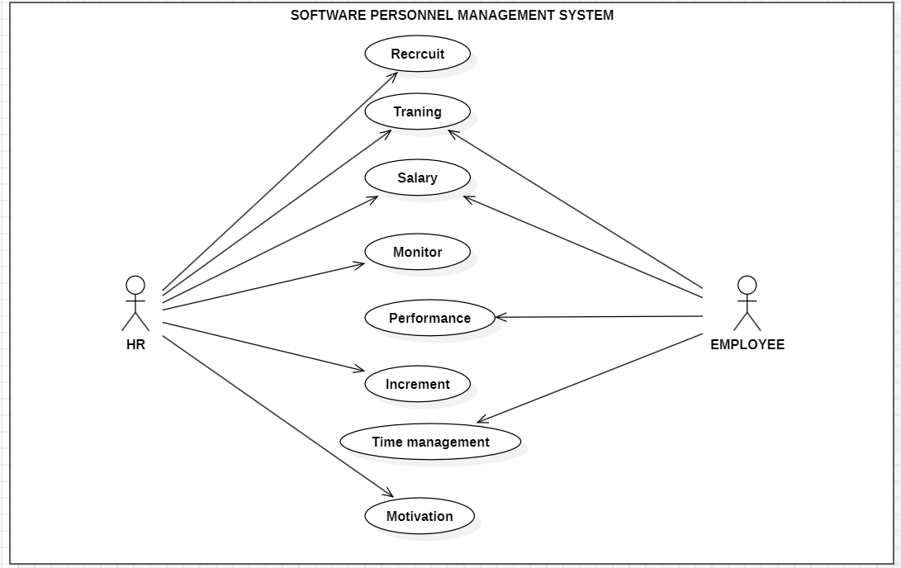

7.2 Activity Diagram
An Activity Diagram models the workflow or business processes in the system. For instance, it shows how leave requests are processed:
- Process for Leave Request:
  - Employee submits a leave request.
  - System checks if the employee has enough leave balance.
  - If yes, HR/Admin receives a notification for approval.
  - HR/Admin reviews the request and approves or rejects it.
  - If approved, the leave balance is updated.
  - If rejected, the employee is notified.
The diagram highlights the sequence of activities and decision points, ensuring that the flow of work is clear.

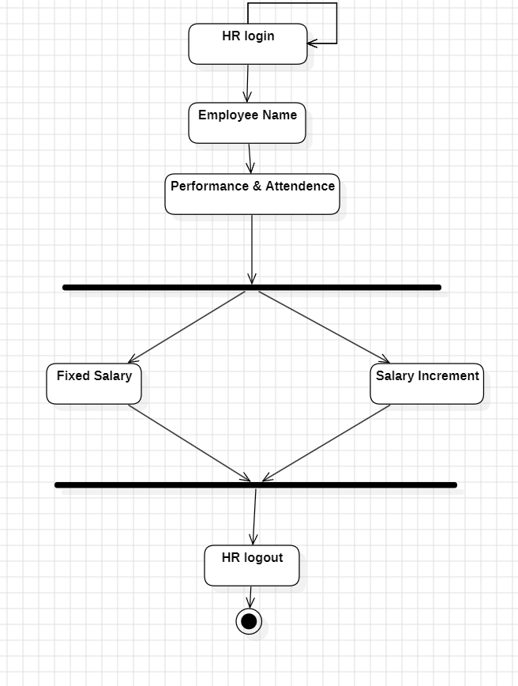
7.3 Sequence Diagram
A Sequence Diagram shows the interactions between system components in a sequential manner, demonstrating how data flows through the system over time. For example:
- Example: Processing Payroll:
  - Admin/HR requests payroll processing.
  - The System retrieves employee salary details from the database.
  - The System calculates the salary (including deductions, bonuses).
  - The System generates salary slips.
  - Admin/HR approves or processes the payroll.
  - System stores payroll data and generates a report.
The sequence diagram visually maps out the time-order interactions between users and system components.
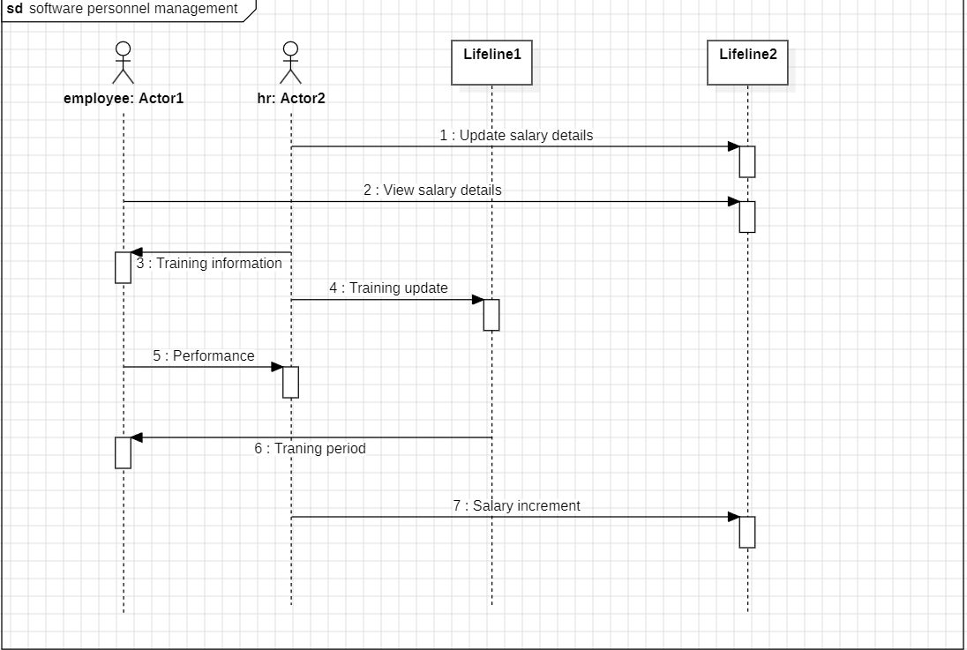
7.4 Class Diagram
The Class Diagram defines the static structure of the system by showing the system's classes, attributes, methods, and relationships among classes.
- Example Classes:
  - Employee:
    - Attributes: employee_id, name, address, department, salary, leave_balance
    - Methods: applyLeave(), viewPerformance()
  - Payroll:
    - Attributes: employee_id, basic_salary, bonus, deductions, net_salary
    - Methods: calculateSalary(), generatePayslip()
  - Leave:
    - Attributes: leave_type, leave_balance, leave_dates
    - Methods: applyLeave(), approveLeave(), rejectLeave()
  - Performance:
    - Attributes: employee_id, review_date, feedback, rating
    - Methods: addPerformanceReview(), viewPerformance()
  - User (Abstract Class):
    - Attributes: user_id, username, password
    - Methods: login(), logout()
  - Admin (inherits from User)
  - HR (inherits from User)
  - Employee (inherits from User)
This diagram clarifies the structure and relationships between the different system components.

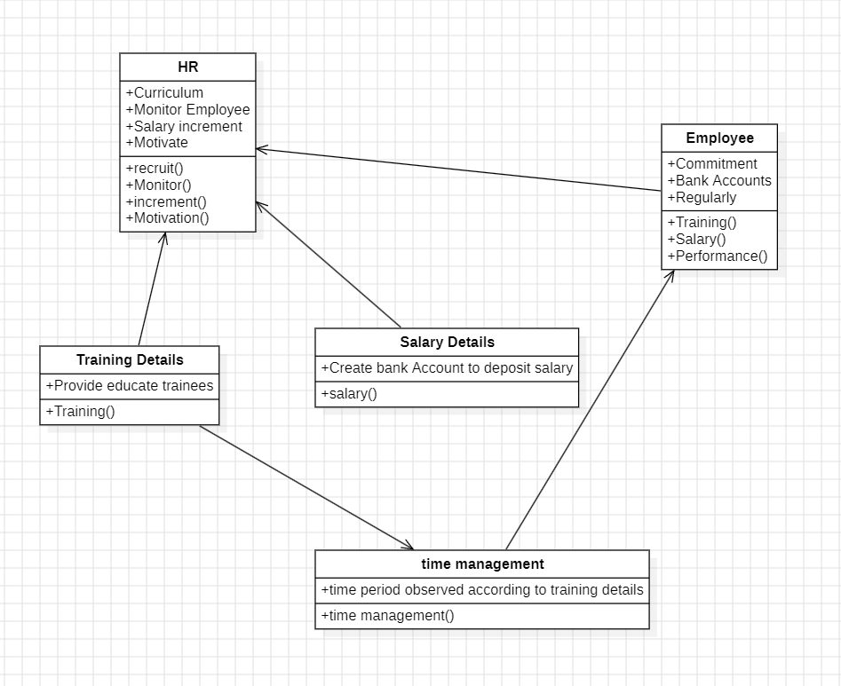

7.5 Collaboration Diagram
The Collaboration Diagram (also known as a Communication Diagram) illustrates the interactions between system objects in the context of a specific use case or scenario. It focuses on the collaboration between objects rather than the time sequence.
- Example: Leave Request Collaboration:
  - Employee sends a request to the Leave object to apply for leave.
  - Leave object communicates with the Employee and HR/ Admin objects to check leave balance and initiate approval.
  - HR/ Admin reviews and updates the leave status.
  - The Leave object updates the system with the decision.
The collaboration diagram emphasizes the relationships and interaction flow between objects.

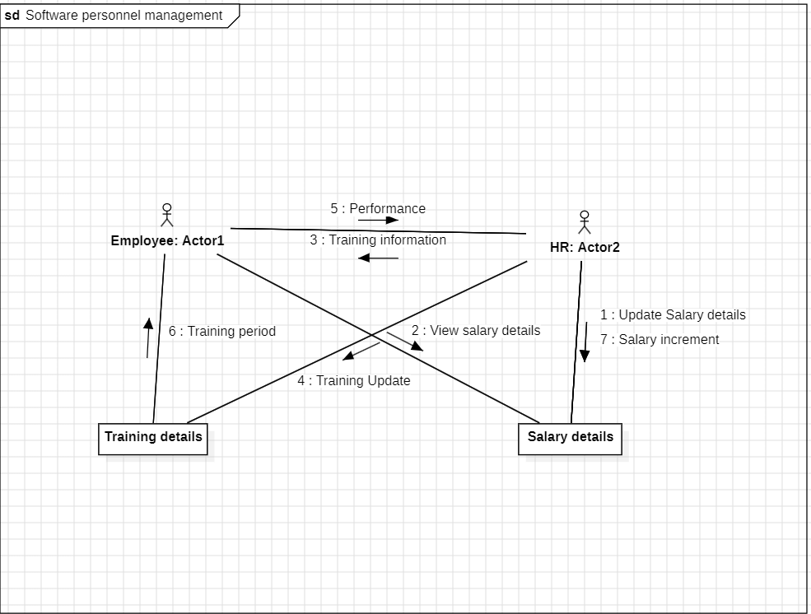

8.SYSTEM IMPLEMENTATION

8.1 Modules of the Project

The SPMS can be divided into several key modules that work together to manage employee records, payroll, leaves, and performance evaluations. Below are the primary modules of the system:
- Employee Management Module
- Payroll Management Module
- Leave Management Module
- Performance Tracking Module
- User Authentication and Authorization Module
- Reports and Analytics Module

8.2 Module Description
Here’s a breakdown of each module's functionality:
1. Employee Management Module
- Purpose: This module allows HR and Admin to manage employee details, including personal information, job roles, departments, and contact information.
- Features:
  - Add, update, and delete employee records.
  - Search and filter employees by name, department, or job role.
  - View employee profiles with details like contact info, joining date, and employment status.
  - Generate reports of all employees or based on specific criteria.
- Payroll Management Module

- Purpose: The Payroll Management module handles the calculation and processing of employee salaries, including bonuses, deductions, and taxes.
- Features:
  - Calculate and generate salary slips for employees.
  - Track deductions for taxes, insurance, and other benefits.
  - Handle bonuses and incentives.
  - Maintain payroll history for auditing purposes.
  - Secure access to salary information for HR and employees.

- Leave Management Module

- Purpose: This module allows employees to request leaves, and HR/admin can approve or reject leave requests.
- Features:
  - Employees can request different types of leave (sick, vacation, etc.).
  - Leave balance tracking for each employee.
  - HR/Admin can approve, reject, or modify leave requests.
  - Automatically update employee availability status and leave balance.
  - Generate leave reports for auditing and tracking purposes.

- Performance Tracking Module

- Purpose: This module tracks employee performance based on reviews, goals, and feedback.
- Features:
  - Set performance goals for employees.
  - Admin/HR can review employee performance periodically.
  - Track feedback and ratings from managers or supervisors.
  - Generate performance reports for analysis and career development.
  - Notifications and reminders for review cycles.

- User Authentication and Authorization Module

- Purpose: This module manages user login and ensures secure access to the system based on different roles (Admin, HR, Employee).
- Features:
  - Secure login page with username and password.
  - User role management (Admin, HR, Employee).
  - Password hashing and encryption for security.
  - Session management to prevent unauthorized access.
  - Reset password functionality and email notifications.

- Reports and Analytics Module

- Purpose: This module provides analytical insights and generates reports for HR and management regarding employee performance, payroll, and leave records.
- Features:
  - Generate customizable reports for payroll, leave, and performance tracking.
  - Graphical representations of key metrics (employee performance trends, leave utilization, etc.).
9.EXPERIMENTAL RESULTS
9.1 Screenshots
9.1.1. Login Page
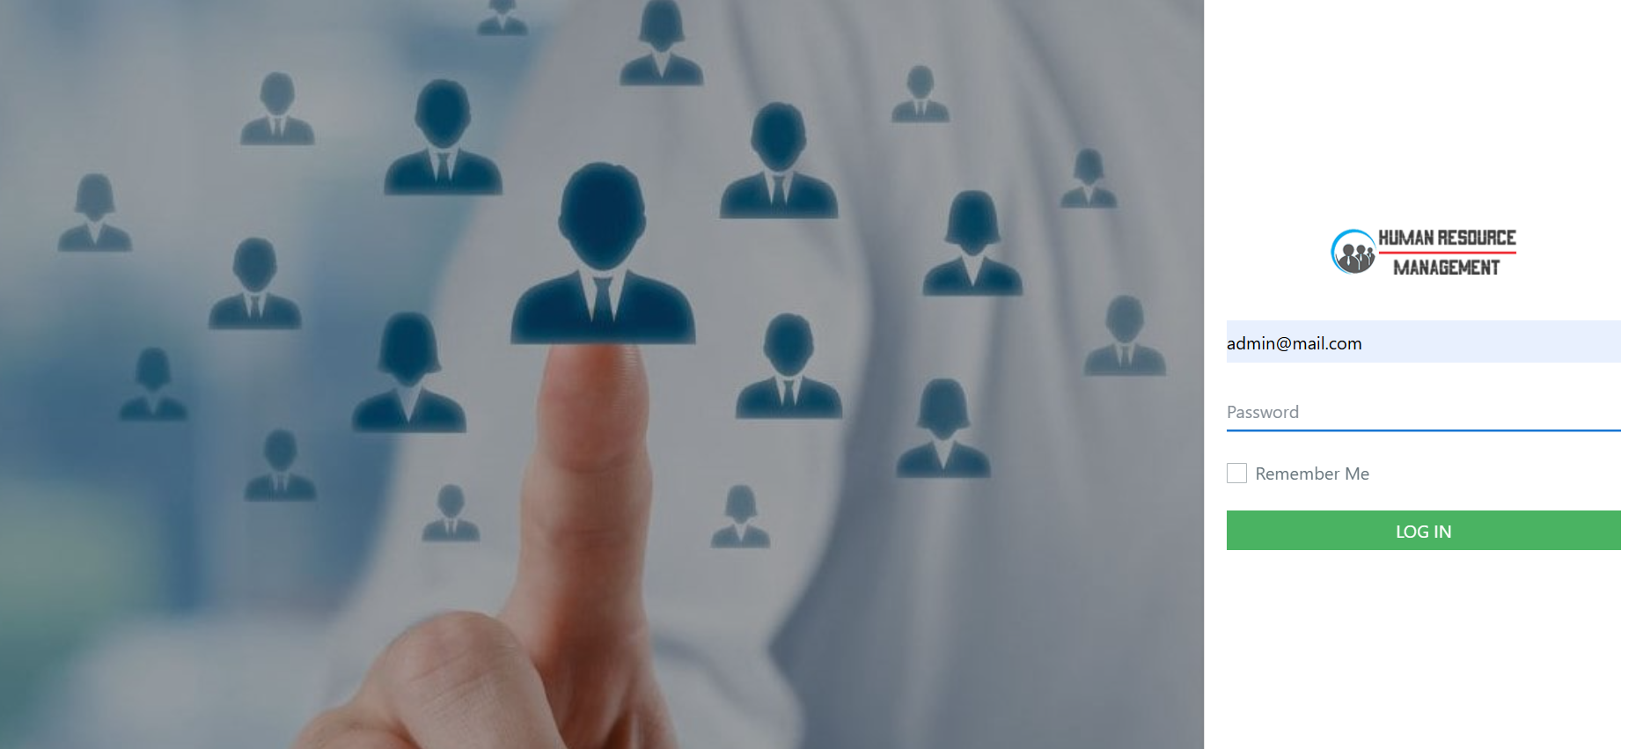

9.1.2. Dashboard:
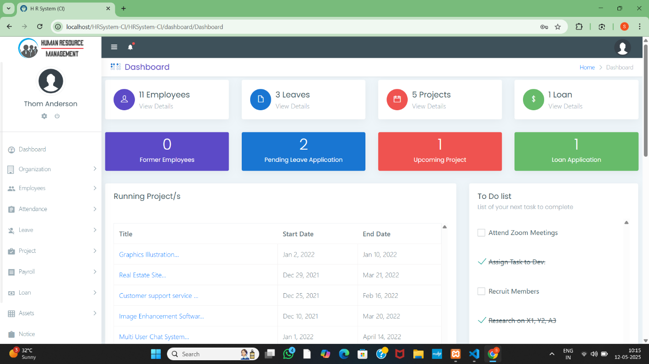
9.1.3. Employee List:
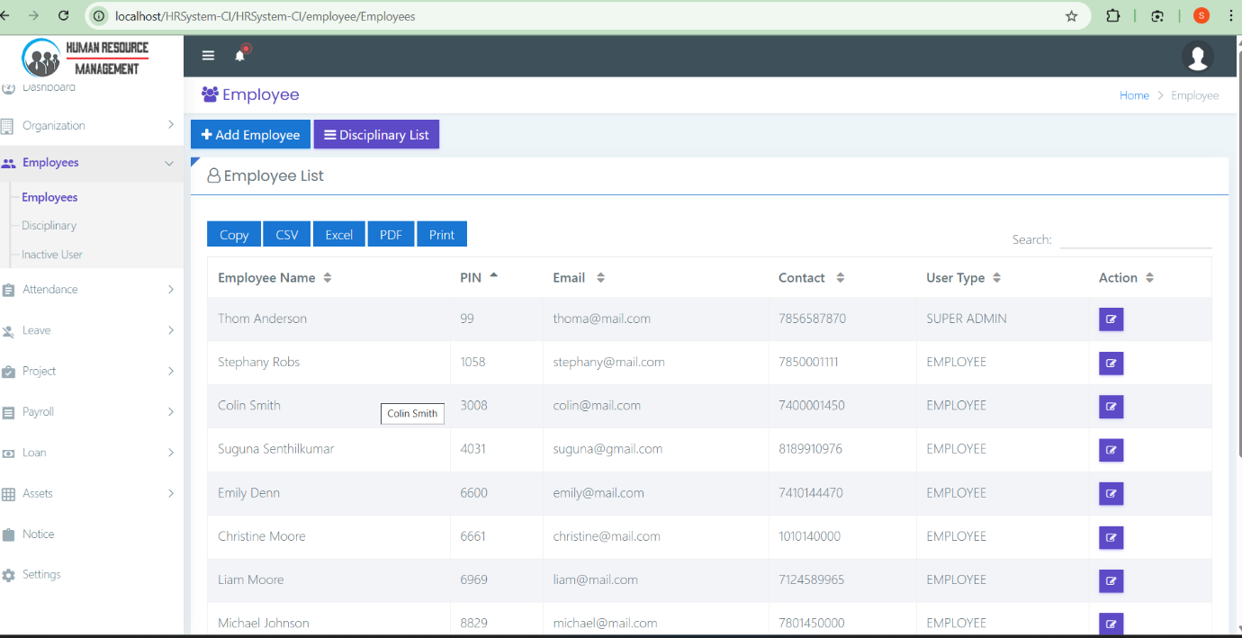

9.1.4. Employee Disciplinary:
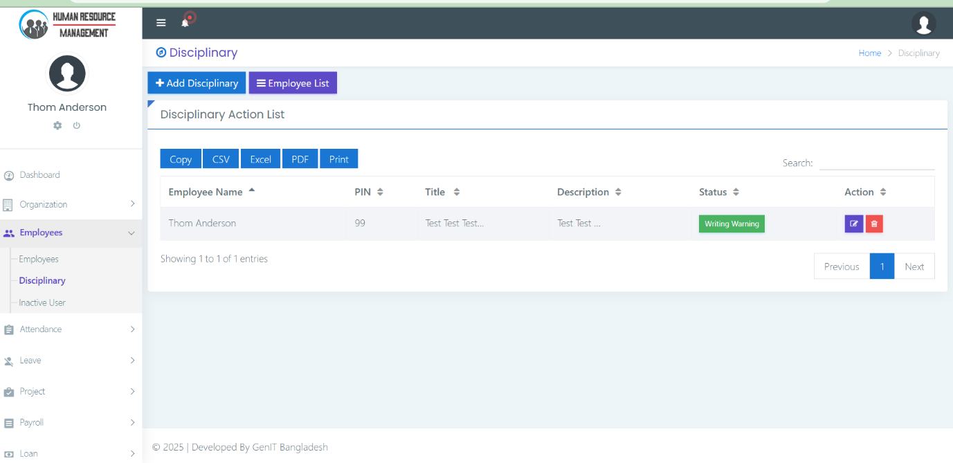

9.1.5. Attendance:
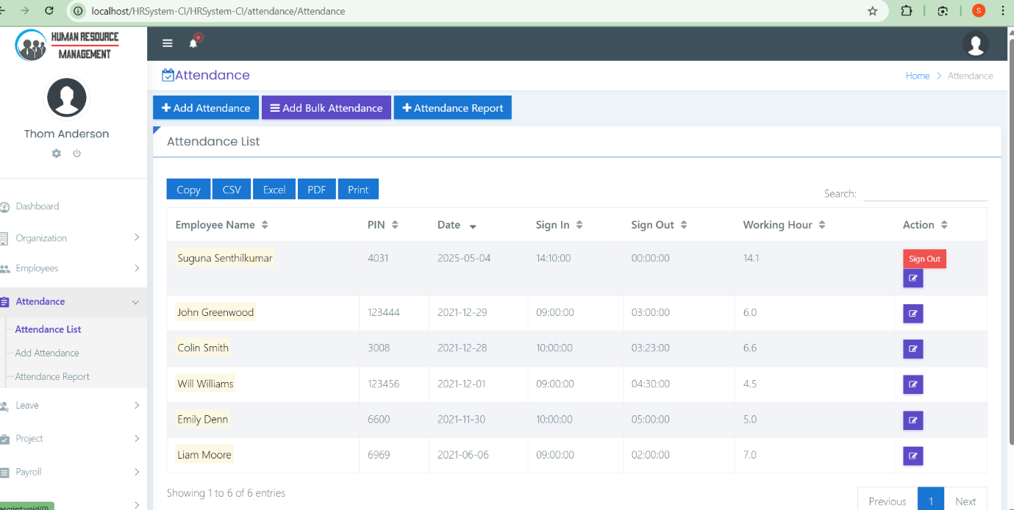

9.1.6. Add Attendance:
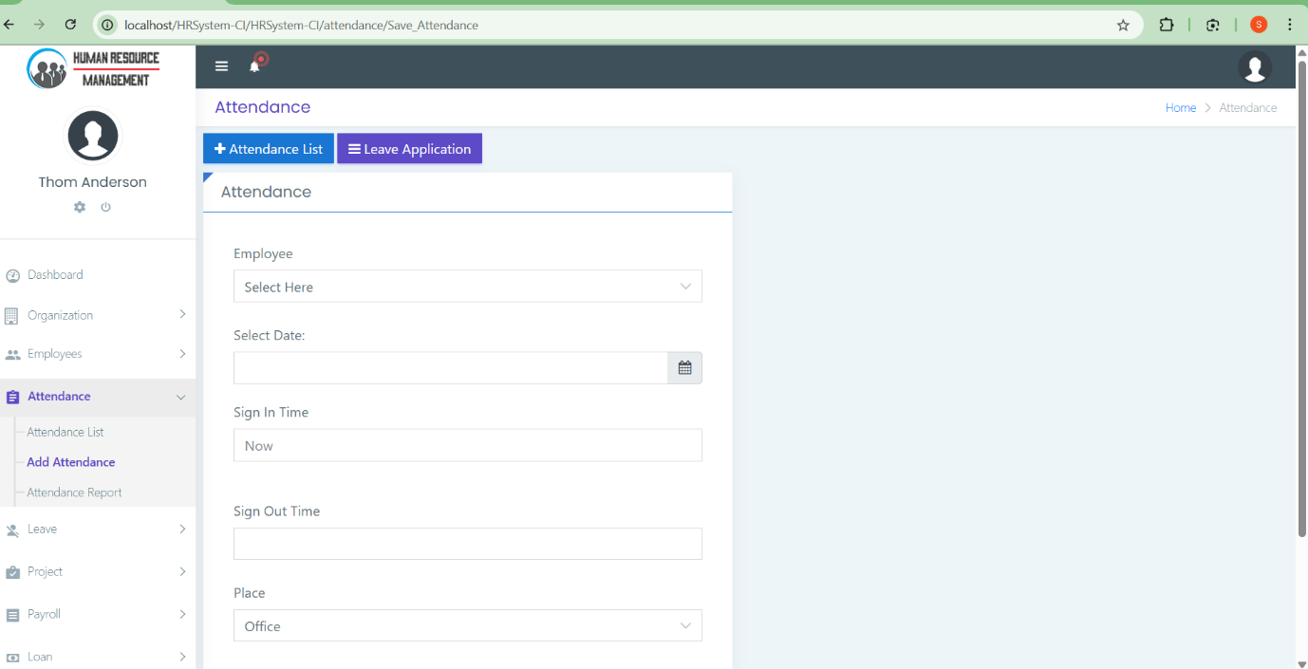

9.1.7. Attendance Report:
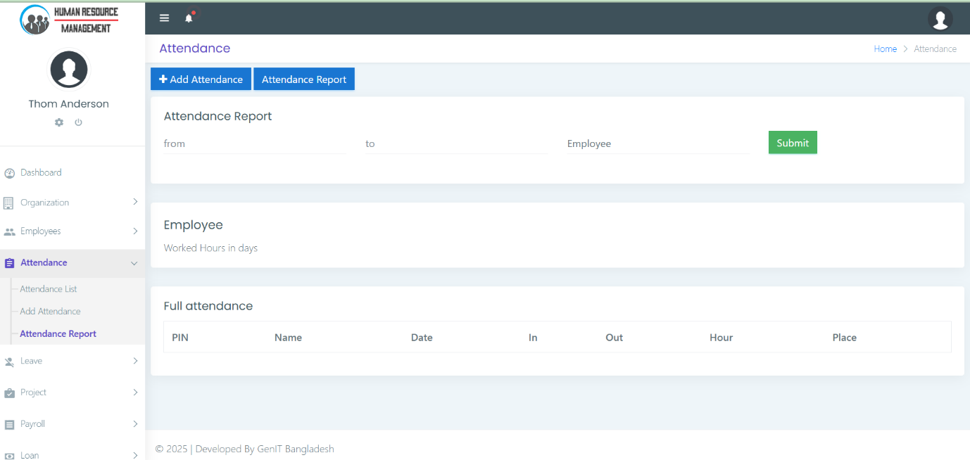

9.1.8. Leave Application List:

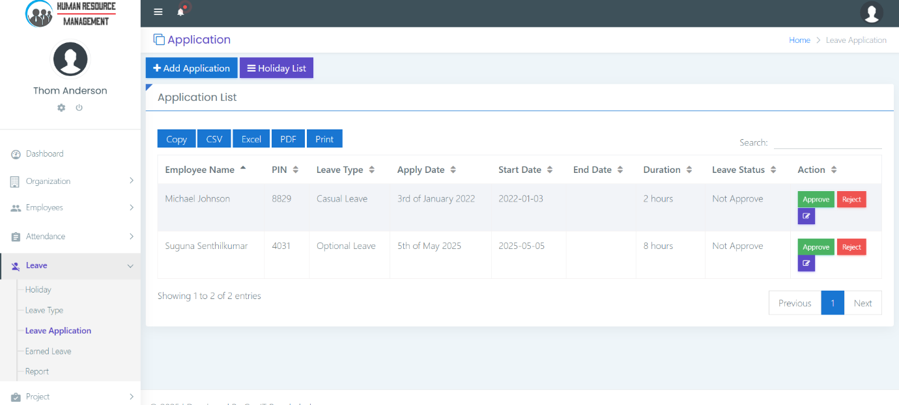

9.1.9. Leave Report:

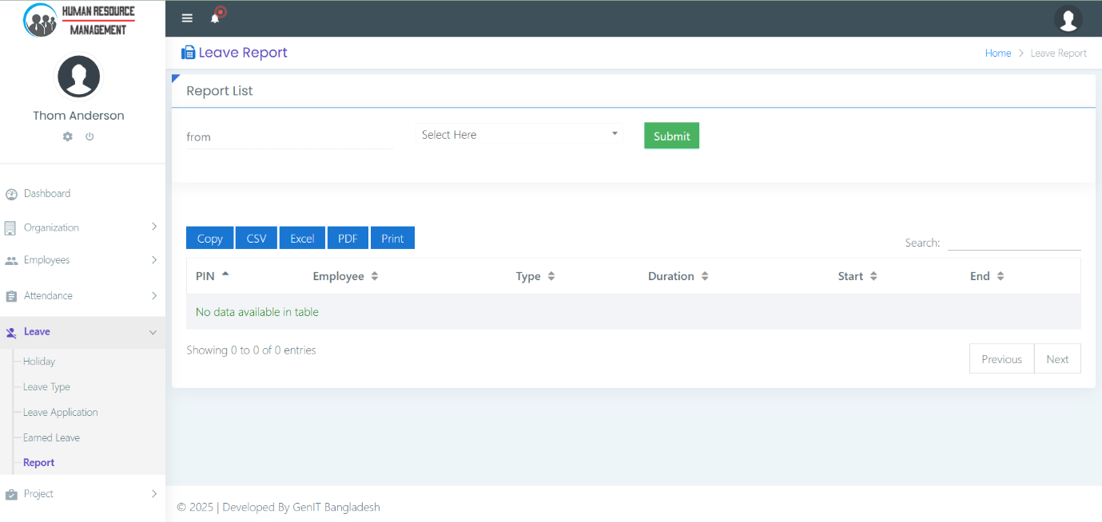

9.1.10. Project List:
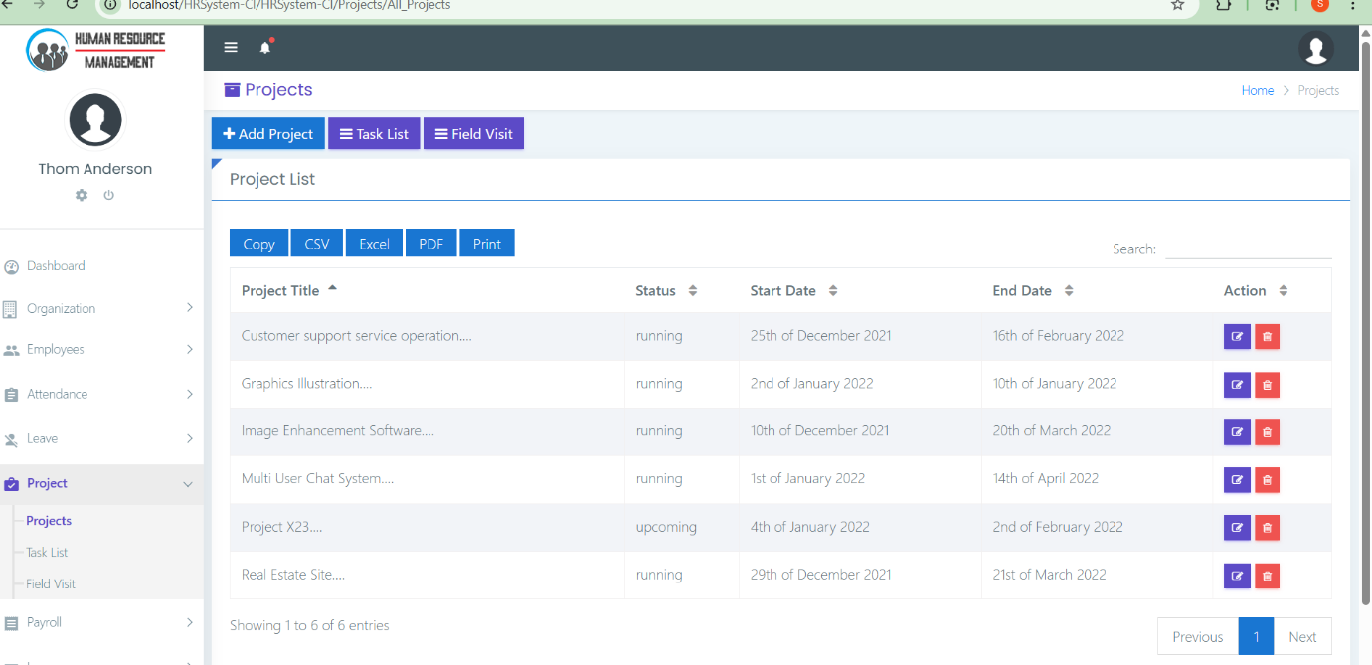
9.1.11. Task List:
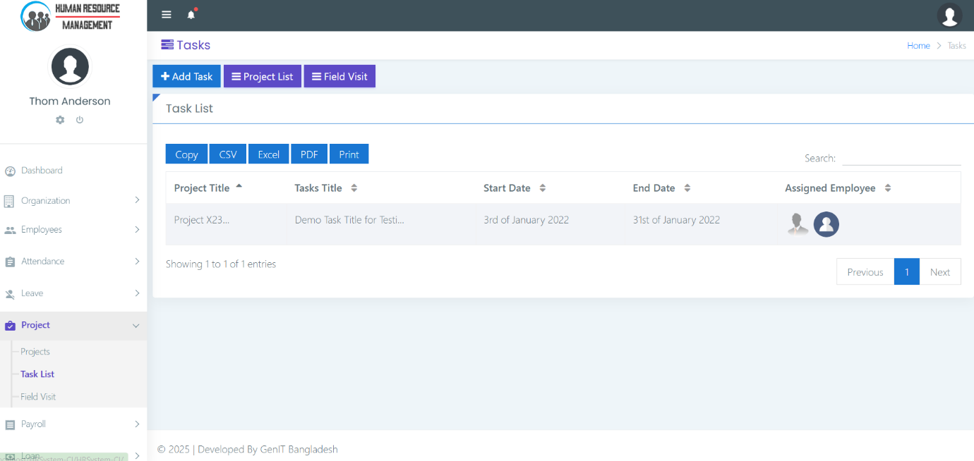

9.1.12. Payroll:
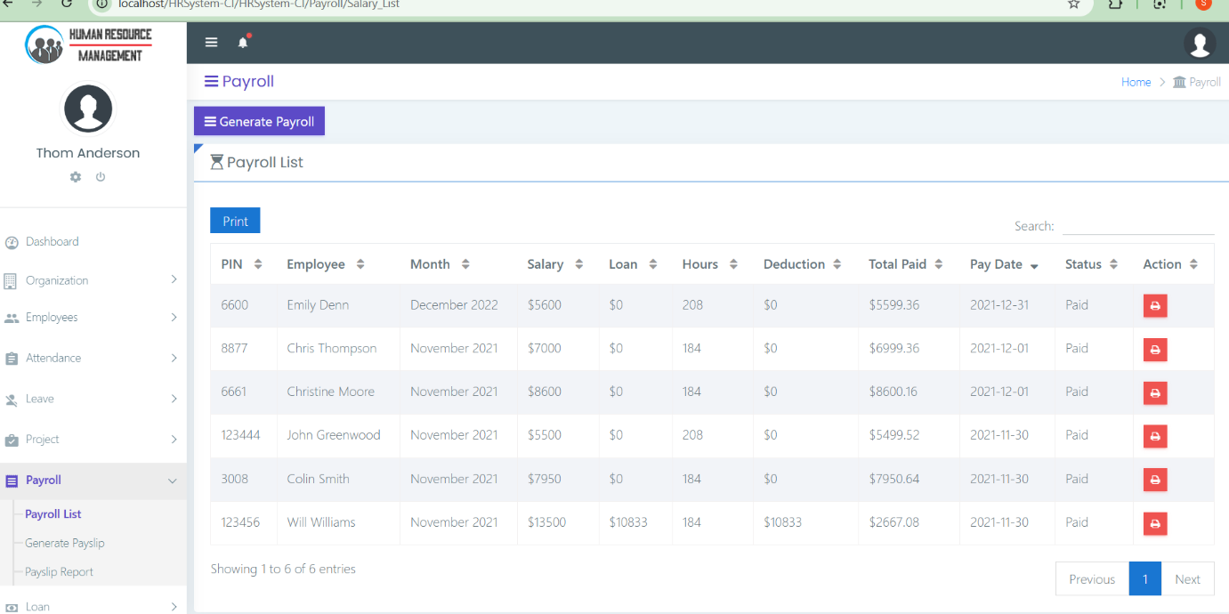

9.1.13. Generate Payslip:
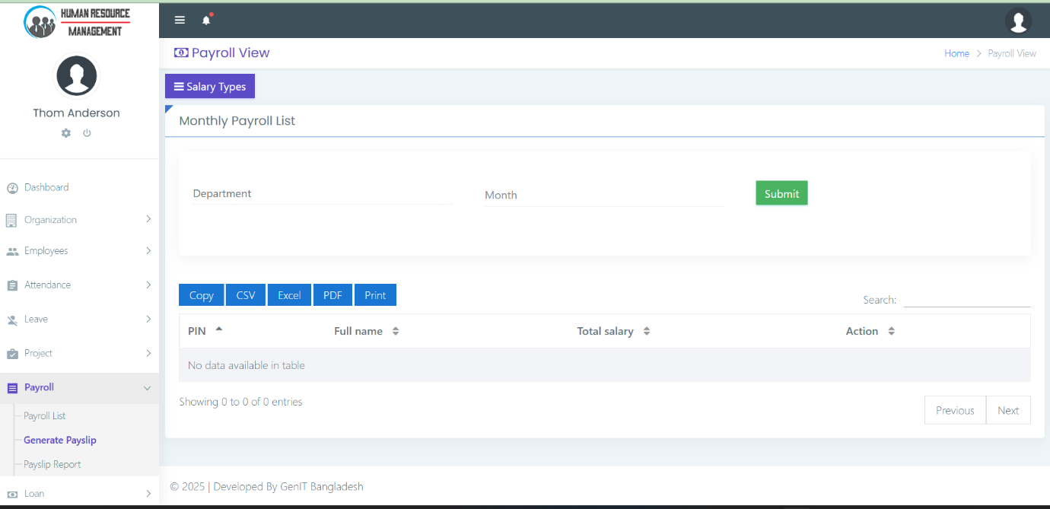

9.1.14. Notice Board:
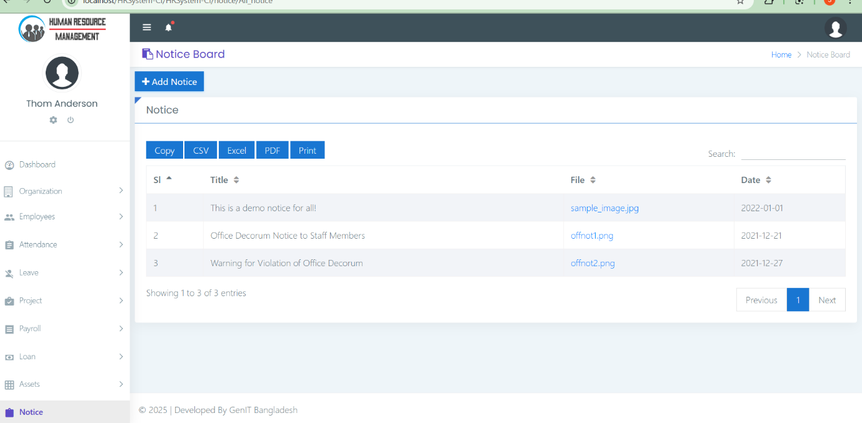

10. RESULTS AND FINDINGS

10.1 Performance Evaluation

- System Functionality:
  - The system has been successfully implemented and tested for all modules: Employee Management, Payroll, Leave Management, and Performance Tracking.
  - Accuracy of Payroll Calculations: The payroll module is accurate in calculating salaries, deductions, and bonuses based on predefined rules. Test cases were used to validate the correctness of salary computations, and the results matched the expected outcomes.
  - Leave Management Effectiveness: The leave management module was able to track leave balances and approvals efficiently. Employees could apply for leave, and HR could approve or reject requests without any system errors or delays.
  - User Authentication: The user login system worked effectively, ensuring that only authorized users could access specific functionalities based on their roles (Admin, HR, Employee).
  - Performance Tracking: The performance evaluation module provided timely and accurate performance reviews for employees, with all feedback properly stored and accessible.
- System Usability:
  - Ease of Use: Feedback from end users (HR, employees) suggested that the system is intuitive and user-friendly. The UI/UX design, built with Bootstrap, was found to be responsive and accessible on different devices (PC, tablets, mobile phones).
  - Response Time: The system performed well, with response times under 2 seconds for most actions like loading employee records, processing payroll, and generating reports.
  - Error Handling: The system displayed informative error messages and prevented users from submitting incorrect or incomplete forms.
- Security Evaluation:
  - Password Encryption: The user passwords were securely encrypted using PHP's password hashing functions, ensuring the protection of sensitive data.
  - Data Security: Secure connections (HTTPS) were used for communication between the client and the server, reducing the risk of data interception during transmission.

10.3.Inferences

- User Adoption: The system has shown a positive reception among users, with HR and employees finding the system to be more efficient than manual methods.
- Time and Cost Efficiency: The system has resulted in a noticeable reduction in the time spent on administrative tasks (such as processing leave requests and calculating payroll), leading to cost savings and increased productivity.
- System Stability: The system has been stable during testing, with no critical issues or downtime. The use of a MySQL database for storage and PHP for the back-end has proven to be reliable.
- Scalability: While the system currently supports a limited number of employees, the underlying architecture (PHP, MySQL) is scalable, allowing the system to grow as the number of employees or departments increases.

11. CONCLUSION AND FUTURE ENHANCEMENT

11.1 Conclusion

- The Software Personnel Management System has been successfully developed and implemented with all core functionalities working as expected. The system effectively streamlines the processes of employee record management, payroll computation, leave tracking, and performance evaluation.
- The results have shown significant improvements in administrative efficiency, accuracy, and user satisfaction. The security features have been validated, ensuring that employee data remains protected and access is controlled based on user roles.
- This system is a valuable tool for HR departments to manage employee data, reduce manual errors, and facilitate smooth operations.

11.2 Future Enhancement

While the system meets the current requirements, there are several areas for future enhancements:
- Mobile Application: Developing a mobile version of the system would make it even more accessible to employees and HR, allowing them to interact with the system from smartphones and tablets.
- Integration with External Systems: The system could be enhanced by integrating with external accounting, payroll, or HR systems, providing a more comprehensive solution.
- AI-Powered Analytics: Implementing machine learning algorithms to analyze employee performance trends and provide predictive insights could assist HR in making data-driven decisions.
- Automated Leave and Salary Adjustments: Future versions of the system could include automated adjustments for leave balances and salary increments based on predefined rules or employee performance metrics.
- Cloud Deployment: Deploying the system on the cloud (AWS, Google Cloud, etc.) could increase scalability, reduce infrastructure costs, and enable access from anywhere, which is especially useful for organizations with remote employees.

12. REFERENCES

- Books and Articles:
  - "PHP and MySQL Web Development" by Luke Welling and Laura Thomson.
  - "Web Security for Developers" by Malcolm McDonald.
- Websites:
  - PHP Documentation (https://www.php.net/)
  - MySQL Documentation (https://dev.mysql.com/doc/)
  - Bootstrap Framework (https://getbootstrap.com/)
- Research Papers:
  - "A Review on Web-based HR Management Systems" – International Journal of Computer Science and Engineering.
  - "Cloud-Based Personnel Management Systems: A Review" – International Journal of Business Management.

